HEALTH MYTHS: BUSTED!
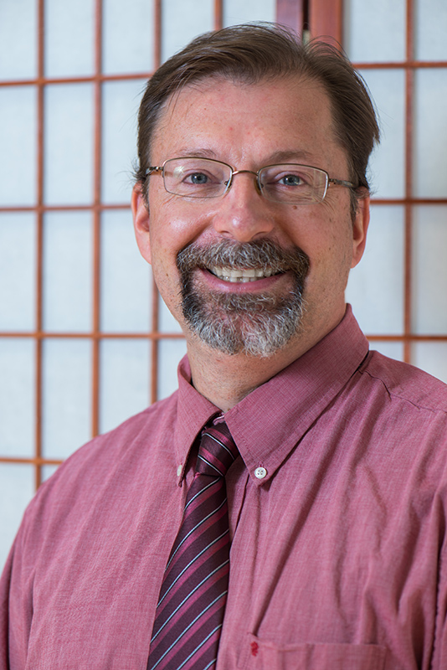
Dr. Kenneth Hoffman, DACM,LAc Medical Director, SOPHIA natural health www.inm.center

Is drinking milk better than taking calcium? Will eggs raise my cholesterol? Can I beat diabetes naturally? Learn the facts vs. the myths about health and wellness today

Wednesday, February 14, 2018
12:30 PM
White Hall, room 127
WCSU, Midtown Campus - 181 White Street, Danbury, Ct

Students, Faculty, Staff, and the public are invited to this free workshop. Bring your bag lunch and join us! Questions? Contact Christel Autuori at autuoric@wcsu.edu

