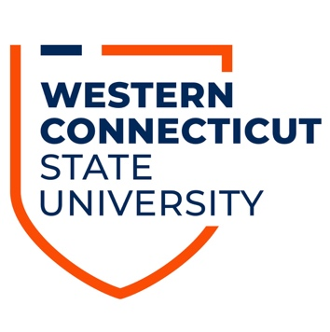

Public Disclosure Information: Teacher Certification
The WCSU teacher certification programs meet the educational requirements for teacher certification or professional licensure in Connecticut. If you plan to work in a state other than Connecticut, WCSU has not made a determination if our programs meet the educational requirements for certification or professional licensure in any other state, Washington DC or Puerto Rico. We recommend that you review the state’s licensing board or teacher certification website for that state’s qualifications. The Associate Dean will complete any necessary forms and/or letters for out-of-state certification on the completion of your approved teacher preparation program.
New York State Teacher Certification: http://www.highered.nysed.gov/tcert/certificate/teachrecother.html

New Jersey State Teacher Certification:
https://nj.gov/education/license/out/

Massachusetts State Teacher Certification:
https://www.doe.mass.edu/licensure/out-state-applicants.html

