

WESTERN CONNECTICUT STATE UNIVERSITY

PERMIT REQUIRED CONFINED SPACE ENTRY

PROCEDURE S-108

Draft Issued 12/97
Revised 2/98; 7/09; 7/16; 11/18; 1/31/2020

Please direct any questions or comments about the applicability of this document to
David Serino, Director of Environmental Health & Safety

1.0 SCOPE AND APPLICATION
This plan is intended to comply with the Occupational Safety and Health Administration (OSHA) Permit - Required Confined Spaces Standard for the General Industry (29CFR 1910.146). The plan and specific work practices and procedures are intended to be at least as stringent as those required by the standard. WCSU is firmly committed to providing each of its employees a safe and healthy work environment. Personnel who are involved in confined space operations are faced with dangers such as oxygen deficient and oxygen rich atmospheres, flammable atmospheres, toxic substances, engulfment hazards, and a whole range of other safety and health hazards. The safety and health of our employees is of the utmost importance. This program establishes guidelines for the protection of those who work in confined spaces.

2.0 PROGRAM AVAILABILITY AND ADMINISTRATION
This program is available to all WCSU employees, their authorized representatives, and outside contractors who may encounter confined spaces while at our facilities. The plan is also available to representatives of OSHA upon request. The Department of Environmental Health and Safety is responsible for the management of all aspects of the plan. If you have any questions regarding the plan, contact the Director of Environmental Health and Safety at 203-837-9319

The success of our Confined Space Entry Program depends, to a great extent, on the cooperation of every employee involved in confined space operations. Employees must observe all danger signs at all permit required confined spaces, never enter a confined space without being trained and/or without authorization, and follow all aspects of this plan. WCSU encourages active employee participation in all safety and health issues to provide all of our employees a safe and healthy working environment.

3.0 DEFINITIONS
Acceptable Entry Conditions means the conditions that must exist in a permit space to allow entry and to ensure that employees involved with a permit confined space entry can safely enter into and work within the space.
Attendant means an individual stationed outside one or more permit spaces who monitors the authorized entrants and who performs all attendant’s duties assigned in the employer’s permit space program.
Authorized Entrant means an employee who is authorized by the employer to enter a permit space.
Blanking or Blinding means the absolute closure of a pipe, line, or duct by fastening of a solid plate (such as spectacle blind or a skillet blind) that completely covers the bore and that is capable of withstanding the maximum pressure of the pipe, line, or duct with no leakage beyond the plate.
Confined Space means:
- Is large enough and so configured that an employee can bodily enter and perform assigned work; and
- Has limited or restricted means for entry or exit (for example, tanks, vessels, silos, storage bins, hoppers, vaults, and pits are spaces that may have limited means of entry); and
- Is not designed for continuous employee occupancy

Double Block and Bleed means the closure of a line, duct, or pipe by closing and locking or tagging a drain or vent valve in the line between the two closed valves.
Emergency means any occurrence (including any failure of hazard control or monitoring equipment) or event internal or external to the permit space that could endanger entrants.
Engulfment means the surrounding and effective capture of a person by a liquid or finely divided (flowable) solid substance that can be aspirated to cause death by filling or plugging the respiratory system or that can exert enough force on the body to cause death by strangulation, constriction, or crushing.
Entry means the action by which a person passes through an opening into a permit required confined space. Entry includes ensuing work activities in that space and is considered to have occurred as soon as any part of the entrant’s body breaks the plan of an opening into space.
Entry Permit means the written permit or printed document that is provided by the employer to allow and control entry into a permit space and that contains the information specified in the standard.
Entry Supervisor means the person (such as the employer, foreman, or crew chief) responsible for determining if acceptable entry is planned, for authorizing entry and overseeing entry operations, and for terminating entry as required by this standard.
Hazardous Atmosphere means an atmosphere that may expose employees to the risk of death, incapacitation, and impairment of ability to self-rescue (that is, escape unaided from a permit space), injury, or acute illness from one or more of the following causes:
- Flammable gas, vapor, or mist in excess of 10 percent of its lower flammable limit (LFL).
- Airborne combustible dust at a concentration that meets or exceeds its LFL.
- Atmospheric oxygen concentration of any substance for which a dose or a permissible exposure limit is published in Subpart G, Occupational Health and Environmental Control, or in Subpart Z, and which could result in employee exposure in excess of its dose or concentration of any substance that is not capable of causing death, incapacitation, impairment of ability to self-rescue, injury, or acute illness due to its health effects is not covered by this provision.
- Any other condition that is immediately dangerous to life or health.
Hot Work Permit means the employer’s written authorization to perform operations (for example, riveting, welding, grinding, cutting, burning, and heating) capable of providing a source of ignition.
Immediately Dangerous to Life or Health (IDLH) means any condition that poses an immediate or delayed threat to life or that would cause irreversible adverse health effects or that would interfere with an individual’s ability to escape unaided from a permit space.
Inerting means the displacement of the atmosphere in a permit space by a noncombustible gas (such as nitrogen) to such an extent that the resulting atmosphere is noncombustible.
Isolation means the process by which a permit space is removed from service and completely protective against the release of energy and material into the space by such means as blanking or blinding, misaligning or removing sections of lines, pipes, or ducts, a double block and bleed system, lockout or tagout of all sources of energy, or blocking or disconnecting all mechanical linkages.
Line Breaking means the intentional opening of a pipe, line, or duct that is or has been carrying flammable, corrosive, or toxic material, in inert gas, or any fluid at a volume, pressure, or temperature capable of causing injury.
Oxygen Deficient Atmosphere means an atmosphere containing less than 19.5% oxygen by volume.
Oxygen Enriched Atmosphere means an atmosphere containing more than 23.5% oxygen by volume.
Permit-Required Confined Space means a confined space that has one or more of the following characteristics:
- Contains or has the potential to contain a hazardous atmosphere
- Contains a material that has the potential for engulfing an entrant
- Has an internal configuration such that an entrant could be trapped or asphyxiated by inwardly converging walls or by a floor which slopes downward and tapers to a smaller cross section
- Contains any other recognized serious safety or health hazard
Permit-Required Confined Space Program means the employer’s overall program for controlling, and where appropriate, for protecting employees from permit space hazards and for regulating employee entry into permit spaces.
Permit System means the employer’s written procedure for preparing and issuing permits for entry and for returning the permit space to service following termination of entry.
Prohibited Condition means any condition in a permit space that is not allowed by the permit during the period when the entry is authorized.
Rescue Service means the personnel designated to rescue employees from permit space.
Retrieval System means the equipment (including a retrieval line, chest or full body harness, wristlets, if appropriate, and a lifting device or anchor) used for non-entry rescue of persons from permit spaces.
Testing means the process by which the hazards that may confront entrants of a permit space are identified and evaluated. Testing includes specifying the tests that are to be performed in the permit space.

4.0 CONFINED SPACE EVALUATION AND CLASSIFICATION
Every confined space in WCSU shall be evaluated to determine if any spaces in the work place are permit required confined spaces. For the purposes of determining if a space is a confined space, the following definition is used. “Confined Space” means that:
- Is large enough and so configured that an employee can bodily enter and perform assigned work
- Has limited or restricted means for entry or exit (for example, tanks, vessels, silos, storage bins, hoppers, vaults, and pits are spaces that may have limited means of entry)
- Is not designed for continuous employee occupancy

Following the determination of a space as a confined space, the Decision Tree in Appendix A of 1910.146 is used to determine if the space is permit required. To start the flowchart, a “Permit-Required Confined Space” means a confined space that has one or more of the following characteristics:
- Contains or has the potential to contain a hazardous atmosphere
- Contains a material that has the potential for engulfing an entrant
- Has an internal configuration such that an entrant could be trapped or asphyxiated by inwardly converging walls or by a floor which slopes downward and tapers to a smaller cross section
- Contains any other recognized serious safety or health hazard

Although, in some instances, the decision tree does not consider a space a permit required space, WCSU may follow a stricter guideline and call the space a permit required space. If this is the case, it is indicated on the decision tree.

Finally, Appendix B is planned to contain a list of our permit-required confined spaces upon completion of the survey of all confined spaces on campus, as well as a list of our non-permit required confined spaces. If the space is not listed as either a permit required confined or a non-permit required confined space, it will be treated as a permit required confined space until it is properly classified.

For every permit required confined space, a permit required confined space evaluation will be filled out. This form will indicate the location, potential hazards, and control requirements for acceptable entry, special instructions for entry, anticipated signs or symptoms of exposure, rescue information, and anticipated classification of the space.

All of our non-permit required confined spaces will have, at minimum, atmospheric testing prior to entrance in order to ensure that conditions have not rendered the space permit-required.

5.0 POSTING OF PERMIT REQUIRED CONFINED SPACE
If it is not feasible to post the sign, specify how workers will be informed and the rationale for not posting the sign.

Additionally, all regular confined spaces will also be posted, if feasible, with a sign containing the same or similar language stated below.

DANGER
PERMIT-REQUIRED CONFINED SPACE
DO NOT ENTER

- PERMIT-REQUIRED CONFINED SPACE ENTRY PERMIT AND ENTRY

PROCEDURES
6.1 ENTRY PERMIT
Prior to the entry into a permit-required confined space, an entry permit shall be prepared by an individual competent to prepare such permits. Authorized personnel have been trained in the proper condition and calibration of equipment to meet this criteria. In some instances, a competent outside consultant may be used. The permit shall document the following information:
- The space to be entered
- The purpose of entry
- The date and the authorized duration of the entry permit
- The authorized entrants within the permit space (tracking system with entry and exit times)
- The personnel currently serving as attendant(s)
- The individual serving as entry supervisor, who originally authorized entry
- The hazards of the permit space to be entered
- The measures used to isolate the permit space and to eliminate or control permit space hazards before entry
- Acceptable entry conditions
- The results of initial and period tests accompanied by the name or initials of the testers and by an indication of when the tests were performed
- Rescue and emergency services that can be summoned and the means for summoning those services
- The communication procedures used by authorized entrants and attendants to maintain contact during entry
- Equipment, such as personal protective equipment, testing equipment, communications equipment, alarm systems and rescue equipment, to be provided
- Any other information whose inclusion is necessary in order to ensure employee safety
- Any additional permits, such as for hot work, that have been issued to authorize work in the permit space

Appendix C contains our permit-required confined spaces entry permits.

Before entry begins, the entry supervisor identified on the permit shall verify that all necessary precautions have been taken and then sign the entry permit to authorize entry.

The completed permit will be made available to all authorized entrants by posting it at the entry portal so that the entrants can confirm that pre-entry preparations have been completed.

The duration of the permit will not exceed 8 hours and will not exceed the time required to complete the task identified on the permit.

Additionally, if a task other than the specific task identified on the permit is to be accomplished, a new permit will be issued.

The entry supervisor shall terminate entry and cancel the entry permit when:
- The entry operations covered by the entry permit have been completed, or
- A condition that is not allowed under the entry permit arises in or near the permit space.

When the job is complete all entrants have exited the space and the space is ready to be returned to normal services, the entry supervisor shall debrief personnel involved in the entry and cancel the permit. Any problems encountered during an entry operation shall be noted on the permit so that appropriate revisions to the permit space can be made.

All entry permits will be retained for at least one year to facilitate the review of this program.
6.2 ENTRY PROCEDURES
Prior to entry of a permit-required confined space, an entry permit will be filled out. All pre-entry activities specified on the permit shall be met.

These preparations may include, but are not limited to, the following, depending on the Permit-Required Confined Space Evaluation Form:
- Isolating the permit space
- Depressurizing equipment under positive or negative pressure
- Lockout/Tagout and tryout all sources of electrical, pneumatic, mechanical, chemical, thermal, or radiation hazards
- Purging, inerting, flushing, or ventilating the permit space as necessary to isolate the area to protect entrants from external hazards
- Providing pedestrian, vehicle, or other barriers as necessary to isolate the area to protect entrants from external hazards
- Any conditions making it unsafe to remove the entrance cover to the confined space shall be removed prior to opening the entrance
- When entrance covers are removed, the openings shall be promptly guarded with railing, temporary cover, or other temporary barrier that will prevent and that will protect each employee working from falling into or entering the space, and from objects falling into the space
- Before an individual enters the space, the internal atmosphere shall be tested with calibrated, direct reading instrumentation for the following conditions (note Calibration Documentation, Appendix F) in the order listed below:
- oxygen content
- flammable gases and vapors
- potential toxic air contaminants
- There shall be no hazardous atmosphere within the space whenever any employee is inside the space.
- Continuous forced ventilation shall be used as follows:
- An employee may not enter the space until the forced air ventilation has eliminated any hazardous atmosphere.
- If forced air ventilation is used, it shall be so directed as to ventilate the immediate areas where an employee is or will be present within the space and shall continue until all employees have left the space.
- If forced air ventilation is used, it shall be from a clean source and may not increase the hazards in the space.
- The atmosphere within the space shall be continuously monitored.
- At least one attendant will be outside the permit required confined space into which entry is authorized.
- The permit required confined space will be immediately evacuated under any of the following conditions:
- A prohibited condition is detected by the supervisor, attendant or entrant
- The supervisor, attendant, or entrant recognizes any warning sign or symptom of exposure to a dangerous situation
- The supervisor, attendant, or entrant detects the behavioral effects of the hazard in an authorized entrant
- The supervisor, attendant, or entrant detects a situation outside the space that could endanger the authorized entrant. If the attendant cannot effectively and safely perform all the required duties
- If a hazardous atmosphere is detected during entry:
- Each employee shall leave the space immediately
- The space shall be evaluated to determine how the hazardous atmosphere developed
- Measures shall be implemented to protect employees from the
- hazardous atmosphere before any subsequent entry takes place

7.0 ALTERNATE PERMIT PROCEDURES
Alternate procedures for entering a permit space apply when all of the following conditions apply:
- The only hazard posed by a permit space is an actual or potential hazardous atmosphere
- Continuous forced air ventilation alone is sufficient to maintain the permit space for entry
- When the work to be performed within the space does not introduce any additional hazards (e.g., flammable materials or toxic substances)
- The documentation of monitoring and inspection data that supports the above findings.
- If an initial entry of the permit space is necessary to obtain the required monitoring and inspection data, the entry shall be performed under the regular procedures for entering a permit space (including the completion of a Confined Space Entry Permit).
- If a condition exists that makes it unsafe to remove an entrance cover, the unsafe condition shall be eliminated before the cover is removed.
- When entrance covers are removed, the opening shall be promptly guarded by a railing, temporary cover, or other temporary barrier that will prevent an accidental fall through the opening and that will protect each employee from objects that may fall into the confined space.
- Prior to entrance into a confined space, the internal atmosphere shall be tested by a competent person with calibrated, direct-reading instruments for the following in the order listed below (note Calibration Documentation is available in the Environmental Health and Safety Office).
- Oxygen content
- Flammable gases and vapors
- Potential toxic air contaminants
- There shall be no hazardous atmosphere within the space whenever any employee is inside the space.
- Continuous forced air ventilation shall be used, as follows:
- An employee may not enter the space until the forced air ventilation has eliminated any hazardous atmosphere.
- The forced air ventilation shall be so directed as to ventilate the immediate areas where an employee is or will be present within the space and shall continue until all employees have left the space.
- The air supply for the forced air ventilation shall be from a clean source and may not increase the hazards in the space.
- The atmosphere shall be periodically tested as necessary to ensure that the continuous forced air ventilation is preventing the accumulation of a hazardous atmosphere.
- If a hazardous atmosphere is detected during entry:
- Each employee shall leave the space immediately.
- The space shall be evaluated to determine how the hazardous atmosphere developed.
- Measures shall be implemented to protect employees from the hazardous atmosphere before any subsequent entry takes place.

8.0 RECLASSIFICATION OF A PERMIT REQUIRED CONFINED SPACE
A space that is classified as permit required may be reclassified as a non-permit required confined space, using the following procedures:
- If the space has no actual or potential atmospheric hazards and if all hazards within the space are eliminated without entry into the space, the space may be reclassified as a non-permit space for as long as the non-atmospheric hazards remain eliminated.
- If it is necessary to enter the space to eliminate hazards, the permit required confined space procedures must be followed. If testing and inspection during the entry demonstrate that the hazards within the space have been eliminated, the permit space may be reclassified as a non-permit space for as long as the hazards remain eliminated.
- If hazards arise within a permit space that has been declassified, the space will be reevaluated to determine if it is a permit required confined space.

9.0 RESCUE
At least one member of a rescue service who holds current classification in first aid and CPR shall be available. The following is used by WCSU as a rescue service:

Danbury Fire Department

To facilitate non-entry rescue, retrieval systems shall be used whenever an authorized entrant enters a permit space, unless the retrieval equipment would increase the overall risk of entry or would not contribute to the rescue of the entrant. Retrieval systems will meet the following requirements:
- Each authorized entrant shall use a chest or full body harness, with a retrieval line attached at the center of the entrant’s back near shoulder level, or above the entrant’s head. Wristlets may be used in lieu of the chest or full body harness if the employer can demonstrate that the use of a chest or full body harness is not feasible or creates a greater hazard and that the use of wristlets is the safest and most effective alternative.
- The other end of the retrieval line shall be attached to a mechanical device or fixed point outside the permit space in such a manner that rescue can begin as soon as the rescue is necessary. A mechanical device shall be available to retrieve personnel from the vertical permit spaces more than five feet deep.
- If an injured entrant is exposed to a substance for which a Safety Data Sheet (,SDS) is required to be kept on site, that Safety Data Sheet shall be made available to all rescue personnel and medical personnel.

10.0 DUTIES OF PERSONNEL AND TRAINING
Authorized entrant’s duties are as follows:
- Know the hazards that may be faced during entry, including information on the mode, signs, or symptoms, and consequences of the exposure.
- Properly use the equipment required to safely enter the confined space, including equipment for testing and monitoring, ventilating, communication, personal protective equipment, lighting and ingress/egress.
- Communicate with the attendant as necessary to enable the attendant to monitor entrant status and to enable the attendant to alert entrants of the need to evacuate.
- Alert the attendant whenever:
- The entrant recognizes any warning sign or symptom of exposure to a dangerous situation, or
- The entrant detects a prohibited condition
- Exit from the permit space as quickly as possible whenever:
- An order is given by the attendant or entry supervisor
- The entrant recognizes any warning sign or symptom of exposure to a dangerous situation
- The entrant detects a prohibited condition, or
- An evacuation alarm is activated
Attendant’s duties are:
- Knows the hazards that may be faced during entry, including information on the mode, signs or symptoms, and consequences of the exposure.
- Is aware of possible behavioral effects of hazard exposure in authorized entrants.
- Continuously maintains an accurate count of authorized entrants in the permit space and ensures the means used to identify authorized entrants.
- Remains outside the permit space during entry operations until relieved by another attendant.
- Communicates with authorized entrants as necessary to monitor entrant status and to alert entrants of the need to evacuate the space.
- Monitors activities inside and outside the space to determine if it is safe for entrants to evacuate the permit space immediately under the following conditions:
- If the attendant detects a prohibited condition
- If the attendant detects behavioral effects of hazard exposure in an authorized entrant
- If the attendant detects a situation outside of the space that could endanger the authorized entrants, or
- If the attendant cannot effectively and safely perform all the required duties
- Summon rescue and other emergency services as soon as the attendant determines that authorized entrants may need assistance to escape from permit hazard spaces.
- Takes the following actions when unauthorized persons approach or enter a permit space while entry is underway:
- Warn the unauthorized persons that they must stay away from the permit space
- Advise the unauthorized persons that they must exit immediately if they have entered the permit space
- Inform the authorized entrants and the entry supervisor if unauthorized persons have entered the permit space
- Performs non-entry rescue specified by the rescue plan
- Performs no duties that might interfere with the attendant’s primary duty to monitor and protect the authorized entrants
- Knows the hazards that may be faced during entry, including information on the mode, signs or symptoms, and consequences of the exposure
- Verifies that, by checking that the appropriate entries have been made on the permit, all tests specified by the permit have been conducted and that all procedures and equipment specified by the permit are in place before endorsing the permit and allowing entry to begin.
- Terminates entry and cancels the permit when required
- Verifies that rescue services are available and that the means for summoning them are operable
- Removes unauthorized individuals who enter or who attempt to enter the permit space during entry operation.
- Determines that, whenever responsibility for a permit space entry operation is transferred and at intervals directed by the hazards and operations performed within the space, entry operations remain consistent with the terms of the entry conditions maintained.

Training
Training shall be provided so that all employees whose work is regulated by the standard acquire the understanding, knowledge, and skills necessary for the safe performance of the duties assigned. Training is provided to each affected employee:
- Before the employee is first assigned duties under the standard
- Before there is a change in assigned duties
- Whenever there is a change permit space operations that presents a hazard about which an employee has not previously been trained
- Whenever the employer has reason to believe either that there are deviations from the permit space entry procedures or that there are inadequacies of our employees’ knowledge or use of procedures

All training shall establish employee proficiency in all appropriate duties. Appendix I contains all training records. The training documentation will contain each person’s name, the signature of the trainer, and the dates of training.

- CONTRACTORS
When an outside contractor is hired to perform work that involves permit space entry, we shall:
- Inform the contractor that the work place contains permit and non-permit required confined spaces and the permit and entry permits and air testing are required
- Inform the contractor of the elements, including the hazards identified in the spaces
- Provide the contractor a copy of this entire program. The contractor must adhere to this program
- Apprise the contractor of any precautions or procedures that are required while working in or near permit required and non-permit required confined spaces
- Debrief the contractor at the conclusion of entry operations regarding the permit space program and regarding any hazards confronted or created in permit spaces during entry operations
- Coordinate entry operations when employees of more than one employer are working simultaneously as authorized entrants in a permit space, so that employees of one employer do not endanger the employees of any other employer
- Require the contractor to provide us with a copy of their permit required confined space program
- While working at our facility, this plan must be complied with.

12.0 HOT WORK
Many safety steps not needed for confined space or permit required confined space entry are necessary for hot work. We use the following guidelines for hot work. For all hot work, local exhaust ventilation will be used if applicable.

Combustibles:
- Remove or protect combustibles within 35 feet of the hot work.
- If possible, remove all flammable liquids and combustibles such as paper and scrap wood from the confined space. If the materials cannot be removed, they will be shielded with flameproof covers.
- The floor will be swept free of combustibles.
- Fire retardant lagging cloth or fire retardant tarps will be used to protect machinery and other workers from sparks and spatter.
- Combustible walls and floors will be protected with fire resistant covers.
- Welding will not take place on metal walls that have combustible coverings or on pipes that are touching combustible walls.
- All areas around the hot work will be clean.

Fire Hazards:
- Fire extinguishing equipment will be on hand and ready for instant use. Workers will be trained in the use of fire extinguishers.
- A fire watch will be maintained. The watch will continue for at least one-half hour after the hot work is finished.

Hot Work Equipment
- Compressed gas cylinders or welding machines into a confined space.
- All wheel mounted equipment will be blocked to keep it from moving.
- Torches will not be used to soften combustible material
- Equipment will be shut down when not in use.
- If gas welding is stopped for any significant time, the torch valve will be closed, the gas supply will be shut off at a point outside the confined space, and all opened fuel gas or oxygen hoses will be immediately removed after disconnecting them from the torch.

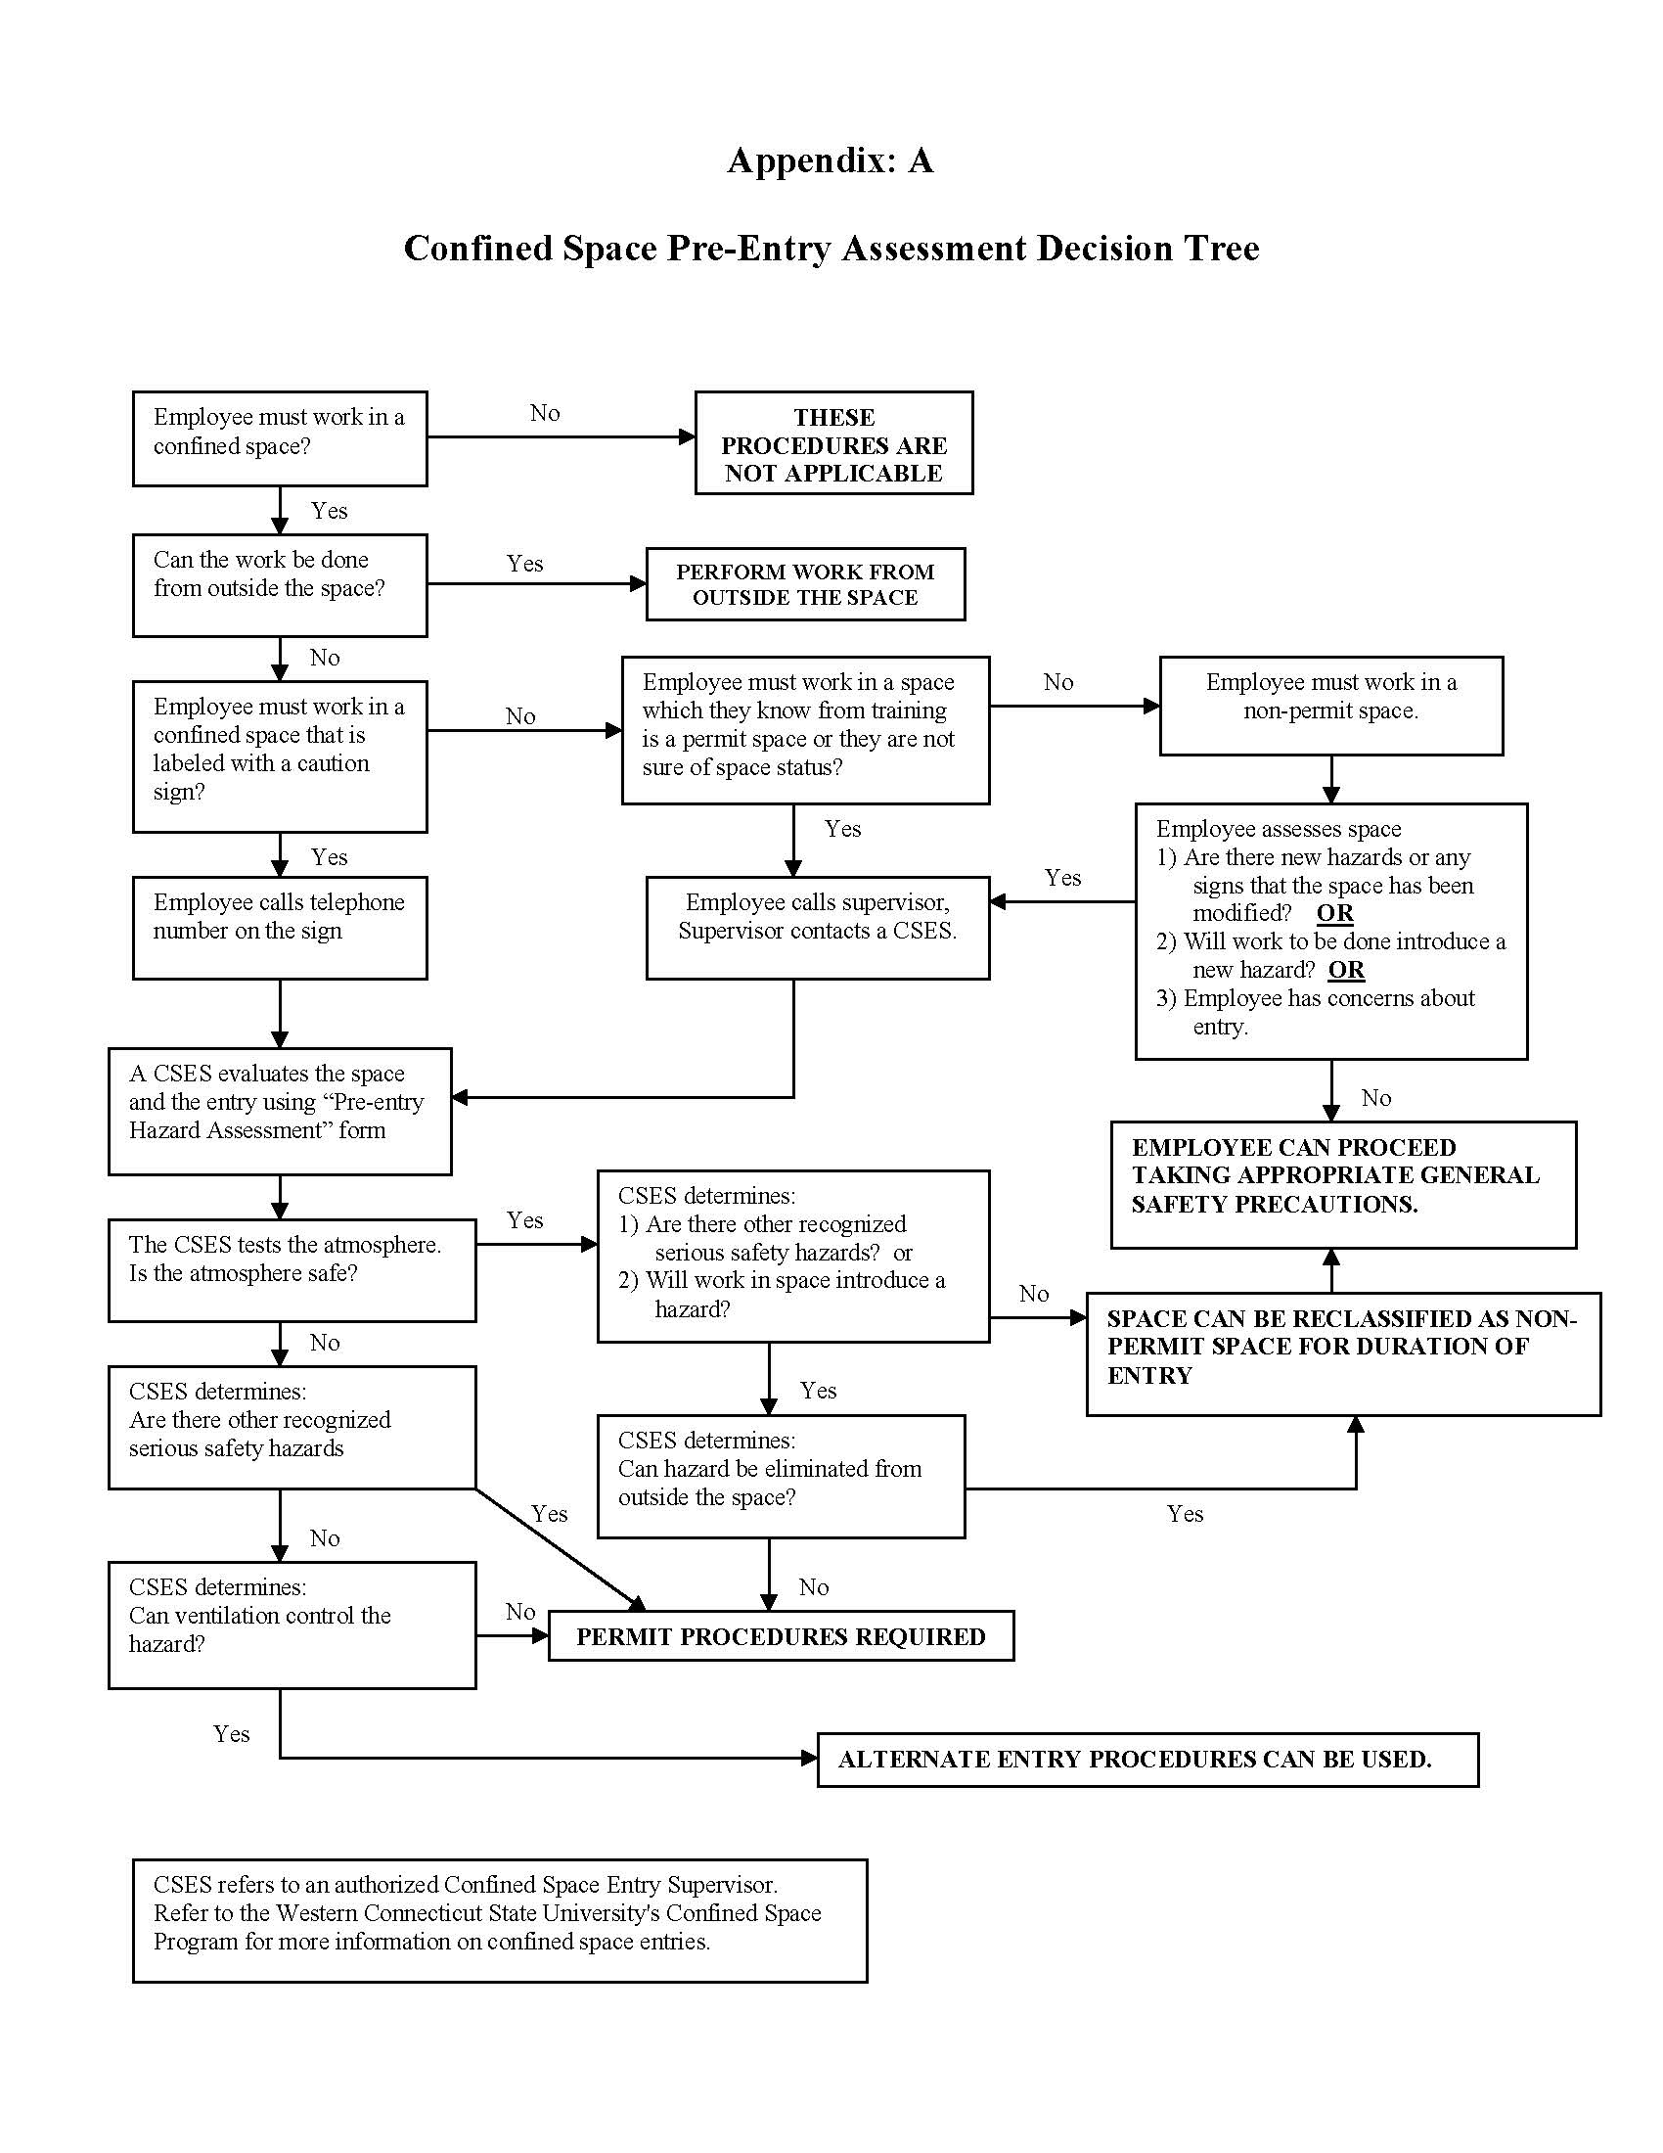

Appendix C:
Permit for Permit-Required Confined Space

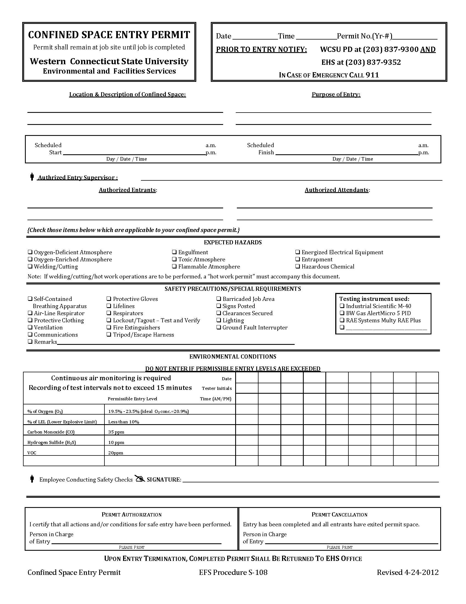

University Certification

Procedure S-108 (Permit Required Confined Space Entry Plan), for the Western Connecticut State University campus located in Danbury, Connecticut, has been reviewed and approved by the appropriate personnel at Western Connecticut State University. The procedures in this plan will be implemented and amended, as necessary, due to expansions, modifications, and improvements at the campus.

Signature: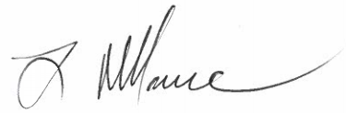 Date: 4/22/2020

Luigi Marcone
Chief Facilities Officer & Associate Vice President for Campus Planning
Telephone Number: (203) 837-9314
Western Connecticut State University
181 White Street
Danbury, Connecticut 06810

