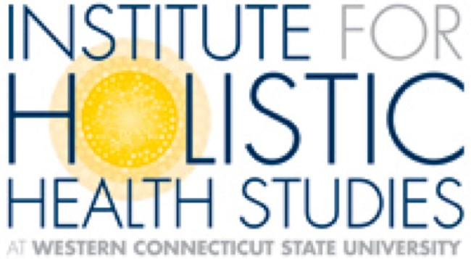
Are Environmental Exposures

A Danger to Your Health?
Presented by Aly Cohen MD FACR
Wednesday, November 13, 2019
7:30 pm Ives Concert Hall
White Hall, WCSU Midtown
181 White Street
Danbury, CT 06810

SPONSOR THE INSTITUTE FOR HOLISTIC HEALTH STUDIES
At Western Connecticut State University

OBJECTIVE
When you partner with IHHS, you become part of a community dedicated to raising awareness and understanding that the most successful path to health and healing is a holistic and integrative approach that combines the best of conventional Western medicine with alternative and complementary healing modalities. The IHHS mission is to provide the university and greater Danbury area with an opportunity to engage in and explore holistic and integrative health through regular programming and instruction

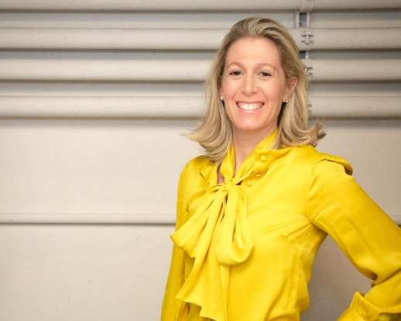

Featured Presenter Aly Cohen MD FACR

Dr. Aly Cohen will discuss evidence-based data on everyday chemicals and EMF exposure and how they contribute to mental health conditions, such as anxiety, depression, and ADHD. She will discuss dietary approaches to reduce toxicity, clean drinking water, beneficial supplements,indoor air quality, sleep hygiene, stress management, and use safe use of cellular technology. Dr. Cohen will provide practical tips and resources to enable and empower students, faculty, and the public on effective ways to limit environmental exposures in order to reduce mental health risks, better manage current conditions, and improve overall well-being!

Dr. Aly Cohen is a rheumatologist, integrative medicine, and environmental health specialist practicing in Princeton, NJ. Her medical practice, that she founded in 2011, Integrative Rheumatology Associates P.C., focuses on both traditional western medical management of rheumatologic and other ailments, as well as integrative options for total “wellness”, such as biofeedback, acupuncture, cognitive therapy, diet and exercise counseling, environmental toxin counseling, smoking cessation, stress management and sleep evaluations.

Dr. Cohen is a regular health contributor to print, radio, and news broadcasts, and lectures nationally on various health topics including integrative medicine, autoimmune disease/inflammation, health effects of everyday chemicals, and cell phone safety. She shares practical vetted health and prevention tips regularly on her award winning, educational platform, The SmartHuman.com and on her Facebook, Twitter, and Instagram feeds for The Smart Human.
Dr. Cohen will have a book signing immediately following the presentation

Ticket Information:
Tickets will ab available at the box office, at the door, and online at www.wcsu.edu/tickets
General Admission $20.
WCSU employees with ID $10.
WCSU students with valid ID Free

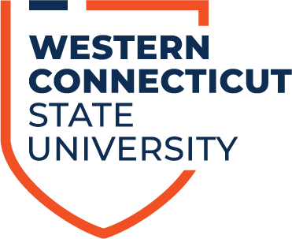

EVENT SPONSORSHIPS
PLEASE CHECK BOX TO INDICATE YOUR LEVEL OF SPONSORSHIP BELOW:

$100 SPONSOR
- Two complimentary tickets to event
- Marketplace table at event with product placement distribution opportunity
- Name in Event Program, on IHHS facebook page and name included in the IHHS annual report

$50 SPONSOR
- One complimentary ticket to event
- Name in Event Program, on IHHS facebook page and name included in the IHHS annual report

EVENT SPONSORSHIP FORM
Business/Individual Name:
Authorizing Contact:
Address:

Phone:

Email:
Social Media Links/Websites:
Thank you for your support!
Please complete this form by October 15, 2019, and send with your check, payable to Institute for Holistic Health Studies to Christel Autuori, Director , IHHS, Berkshire Hall 119C, WCSU, 181 White Street, Danbury, CT 06810 email: autuoric@wcsu,edu Tel. 203.837.8559

