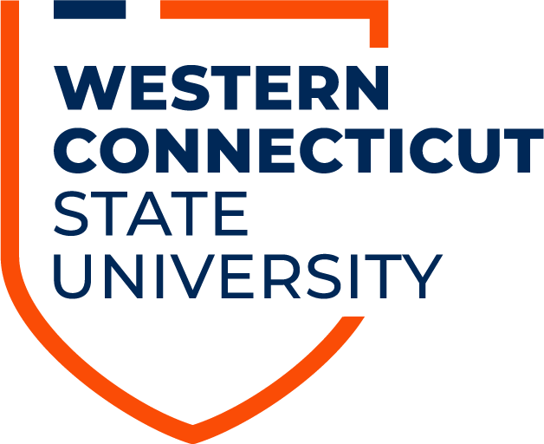
Mascot Advisory Committee
Wednesday, 21 September 2020 | 10:00am
Microsoft Teams Meeting
Agenda
Call to Order
Attendance
Acceptance of Previous Meetings’ Minutes
- 20 July 2020
- 19 August 2020
Public Comment
Unfinished Business
- N/A

New Business
- Subcommittee Report
  - Polling
  - History and Research
  - Board of Regents
- Collecting Submissions
  - Platform (Microsoft Forms, TFA/WordPress)
  - Requirements (Cultural Context, Name)
- Characteristics/Criteria of the Mascot
  - How should this represent the WCSU community?

Adjournment

