Parchment Transcript Orders

step-by-step
The following instructions may be used once a Parchment account has been created. For instructions on creating an account, please refer to the video linked on WCSU Registrar’s Office Transcript page: https://www.wcsu.edu/registrar/forms/transcript/ Parchment may also be contacted directly for assistance: https://www.parchment.com/chat-support/

After logging into Parchment, click on “Orders” tab at the top of the page.
Select one of the following:
- Transcript (email or mail) – use this option to have a transcript sent directly to a third party, or to yourself, either as an official electronic transcript, or a paper (mailed) transcript.
- Local Pickup Transcript – If you would prefer to have your transcript processed at WCSU and made available for pick-up, you should choose this option.
  - You may also choose this option for Apostilled requests – see information on WCSU Registrar’s Office Transcript page: https://www.wcsu.edu/registrar/forms/transcript/

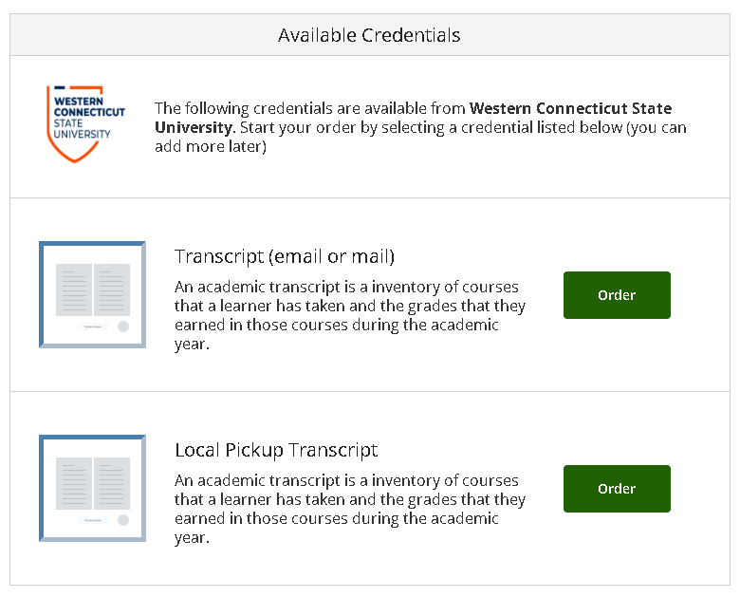
Delivery or Pickup Options

If choosing “Transcript (email or mail)”, the next page will ask for a delivery destination.
Select one of the following:
- Option 1 (see screenshot below) - In the Search box, type the name of the institution to see if they have a “Parchment Receive” account. Schools may have more than one Receive account, so select the option that is the most closely aligned with the reason for your order. (Note: if you do not see the institution, you may choose “Enter Your Own”, located at the bottom of the search window.)
  - You will be brought to an “Item Details” page. From there, you can select several options.
    - Delivery Method - (Note: most institutions will only have an “electronic” deliver method available from the Receive account. If you need to send a paper transcript, you should refer to the instructions under Option 2, below.)
    - “When do you want this sent”? - Choose from “Send Now”, “Hold for Degree”, or “Hold for Grades”. The “hold” options allow you to place an order that will not be released until either the final grades, or degree, have been posted to your official record.
    - Purpose – Choose from a number of options, including “Admission”, “Employment”, etc.
    - “Add An Attachment File” – If there is a document that you must include with your transcript, you can upload it to your order here.
  - “Sign” in the signature box, and be sure to check the “Consent” box underneath, then click “Continue”
  - Review your order information, and click “Complete Order” to send your transcript to the recipient.
- Option 2 (see screenshot below) - Click “I’m sending to myself or another individual” if you have a specific email or mailing address already prepared. A window will appear once you click, and you can select one of the following:
  - “I am sending this order to myself” - (Note: once you have sent a transcript to yourself it is considered unofficial.)
    - Parchment will default to an electronic transcript, and will auto-fill your recipient information, using the email address you created your Parchment account with. You can change this to another email address of yours if needed.
    - You can click on the blue envelope (see below for screenshot) labeled “Print & Mailed” if you’d prefer a paper transcript to be sent. Parchment will auto-fill your information, using the mailing address you supplied when creating your Parchment account. (Note: if you see an orange box that says, “UNABLE TO VALIDATE ADDRESS”, you can either select the suggestion that Parchment provides, if accurate, or you can simply bypass it altogether, and click “Continue”. Parchment attempts to validate the address before sending your transcript, but if you are sure it is correct, you can move forward with your order).
  - “I am sending this order to another individual” –
    - Parchment will default to an electronic transcript, but you can also click on the blue envelope (see below for screenshot) labeled “Print & Mailed” if you’d prefer a paper transcript to be sent.
      - Electronic transcripts require a valid email address, so be sure you are entering the information accurately.
      - Paper transcripts require a valid mailing address, so be sure you are entering all required information, along with any specific details, such as an “attention” note. (Note: if you see an orange box that says, “UNABLE TO VALIDATE ADDRESS”, you can either select the suggestion that Parchment provides, if accurate, or you can simply bypass it altogether, and click “Continue”. Parchment attempts to validate the address before sending your transcript, but if you are sure it is correct, you can move forward with your order).
  - Regardless of which method you select, once you click “Continue”, you will be brought to an “Item Details” page. From there, you can select several options.
    - “When do you want this sent”? - Choose from “Send Now”, “Hold for Degree”, or “Hold for Grades”. The “hold” options allow you to place an order that will not be released until either the final grades, or degree, have been posted to your official record.
    - Purpose – Choose from a number of options, including “Admission”, “Employment”, etc.
    - “Add An Attachment File” – If there is a document that you must include with your transcript, you can upload it to your order here.
  - “Sign” in the signature box, and be sure to check the “Consent” box underneath, then click “Continue”
  - Review your order information, and click “Complete Order” to send your transcript to the recipient.
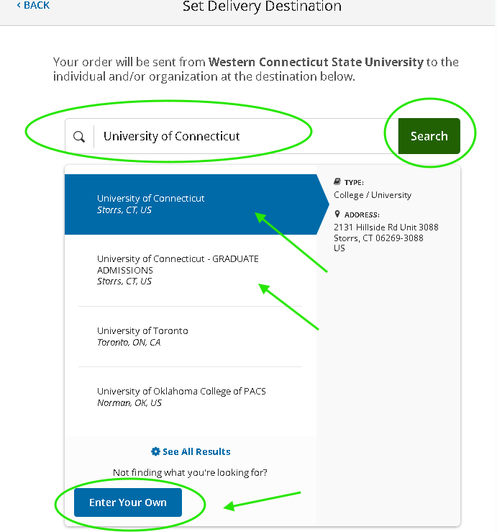
Option 1:

Option 2:
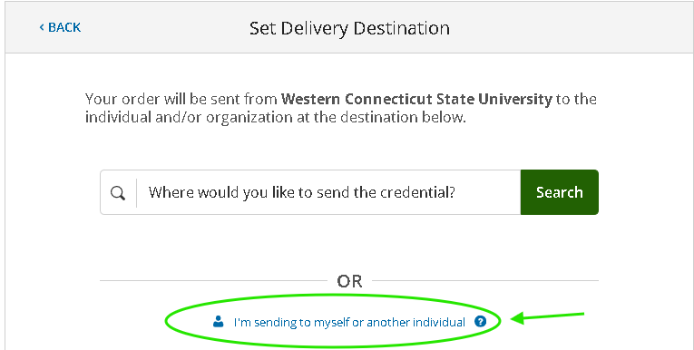

If choosing “Local Pickup”, the next page will be where details about your order can be entered.
Select one of the following:
- “I will be picking this order up myself” (Note: you must bring a legal ID with you to receive your transcript)
  - You will be required to provide a phone number where you can be reached if the Registrar’s Office has any questions.
- “I would like to allow another person to pick this order up on my behalf” (Note: this person must bring a legal ID with them to receive your transcript)
  - You will be required to provide a first and last name of the individual, along with their phone number, in case they need to be reached.
Once you click “Continue”, you will be brought to an “Item Details” page. From there, you can select several options.
- “When do you want this sent”? - Choose from “Send Now”, “Hold for Degree”, or “Hold for Grades”. The “hold” options allow you to place an order that will not be released until either the final grades, or degree, have been posted to your official record.
- Purpose – Choose from a number of options, including “Admission”, “Employment”, etc.
- “Add An Attachment File” – If there is a document that you must include with your transcript, you can upload it to your order here.
- “Sign” in the signature box, and be sure to check the “Consent” box underneath, then click “Continue”
- Review your order information, and click “Complete Order” to send your transcript to the recipient.
You will receive an email when your order is ready. You, or the person you approved, may stop by the Registrar’s Office, located on the first floor of Old Main. The office is open Monday through Friday from 8 am to 4:30 PM, weekends and holidays excepted.

Example of “Print & Mailed” Selection:
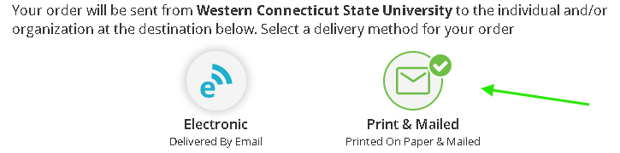

Example of Mailing Address Entry
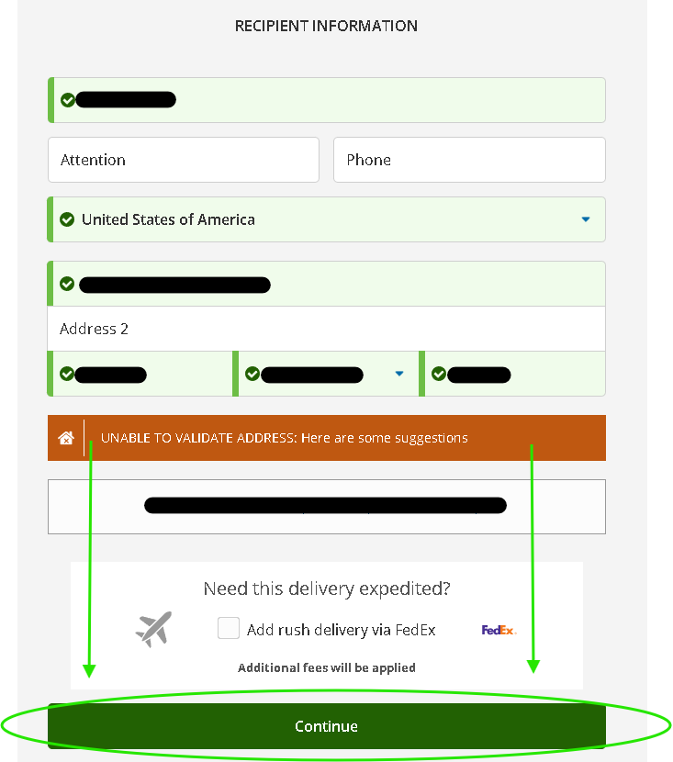

Example of Order Details Entry
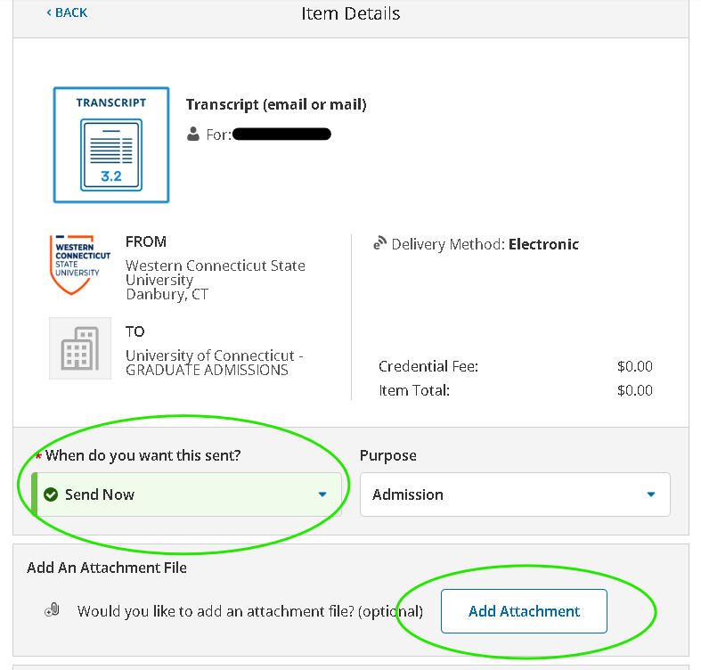
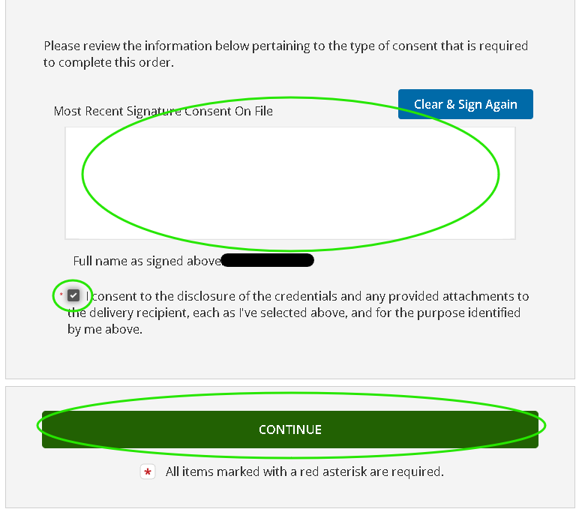
Submitting Your Order 1
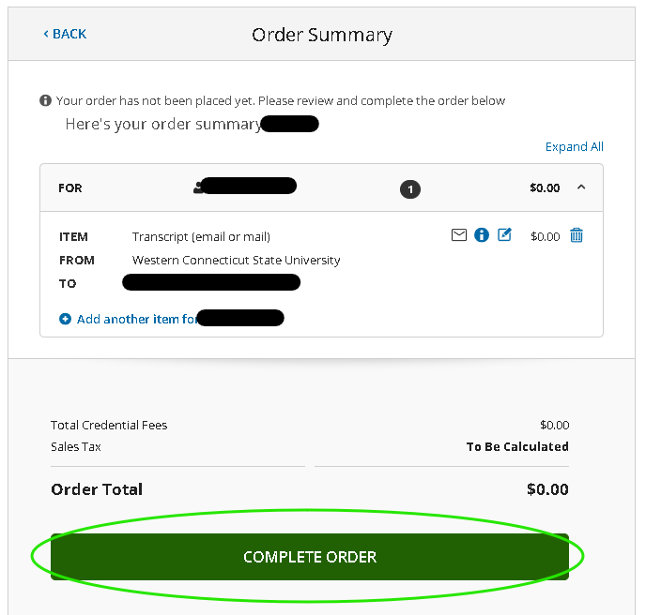

Instructions Last Updated: May 5, 2026

