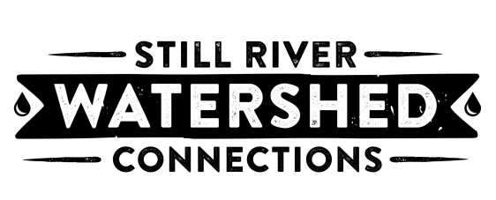

Still River Connections – Aquatic Science
November 5, 2019 Watershed Tour Schedule

Hour 1
8:00 – 8:10 Tour Intro at DHS
8:10 - 8:25 (Drive) DHS to Farrington
8:25 – 9:00 Farrington hike - Headwaters talk + natural healthy streams

Hour 2
9:00 - 9:15 (Drive) Lake Kenosia Park
9:15 - 9:30 Restoration Projects
9:30 - 9:45 (Drive) Still River Canal
9:45 - 10:00 Flooding and Stormwater Talk

Hour 3
10:00 – 10:10 (Drive) DPS Admin Building
10:10 – 10:45 DPS Admin Building Site Assessment Activity
10:45 – 10:50 (Drive) Still River Greenway
10:50 – 11:05 Danbury Greenway Walk

Hour 4
11:05 - 11:25 (Drive) Lovers Leap
11:25 - 11:40 Walk to Confluence
11:40 – 12:00 (Drive) DHS

