Dear Applicant:

Thank you for your interest in the Summer Watershed Steward Ambassador Program (SWSA). This is a Western Connecticut State University program in partnership with Danbury Public Schools, the Housatonic Valley Association’s (HVA) Still River Watershed Connections Program that offers students an opportunity to improve their local outdoor environment and simultaneously develop college readiness skills.

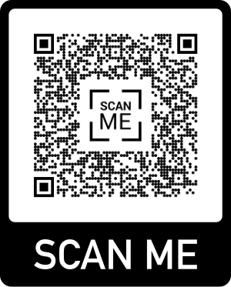
This program will pay you a stipend over 5-weeks to work on HVA’s Still River Watershed Connections Crew and restore habitat that can improve water quality in the Still River and your environmental health. Restoration activities include invasive plant removal (weeding), planting shrubs and bushes along stream banks, cleaning up trash and trail maintenance. All restoration work is done outside. Much like a landscaping work site, you will be using hand tools such as rakes, shovels, clippers/loppers, etc. Prepare to get dirty, sweaty, and have a lot of fun! While in the field you will also participate in citizen science projects such as macroinvertebrate sampling, invasive species mapping, and more! During those 5-weeks you will also work with an instructor and graduate students to build skills for AP environmental science classes and beyond. You will also build connections between your outdoor restoration efforts, civic responsibilities, and authentic environmental issues that you can engage in as a career. One day a week you will meet with instructors to read and discuss data that relate to your restoration work.

Requirements and Details:
- Current Danbury High School Science Students (Junior Status in Aquatic Science Preferred)
- Current 2.3 or higher cumulative GPA
- Interested in working outdoors over the summer

Summer 2022
Dates: July 5th- August 5th
Times: 3 Days: 9am – 1pm Restoration Work (Location dependent on restoration site. Transportation to be provided)
2 Days: 9am-1pm For peer mentoring and AP Environmental Science preparation at the University.
Stipend: 20 hours per week for 5 weeks ($1000 total)

Please go here to apply online: 2022 Online Application Or scan the QR-Code

Deadline: April 15th Special consideration to students who apply by March 4th

If you have any questions, contact Sebastian Palacio, Outreach Coordinator for Finding Our Way,
palacios@wcsu.edu Office Phone: 203-837-8753.

