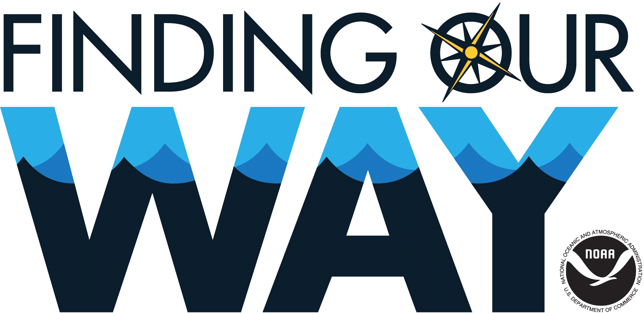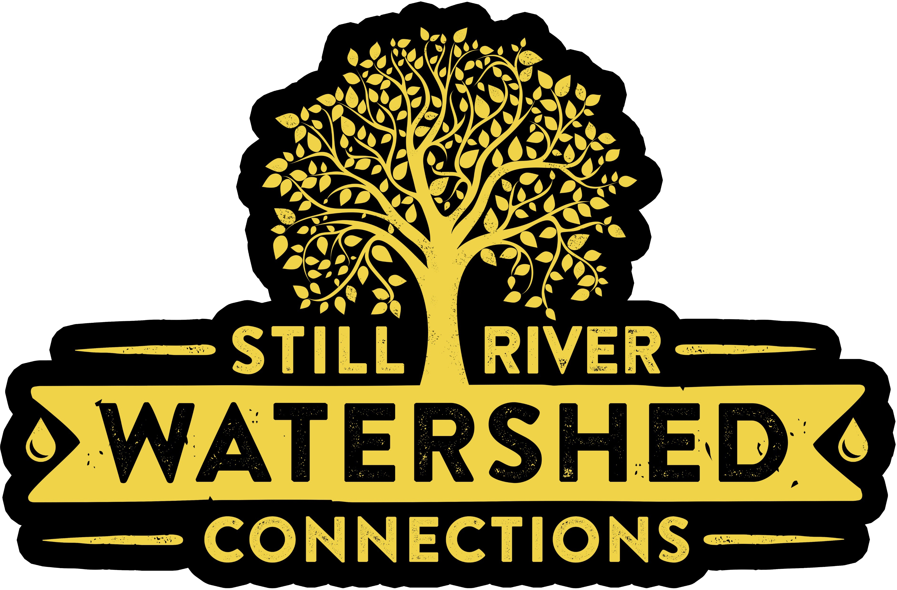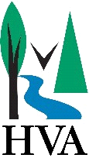
Dear Applicant:
Thank you for your interest in the 2024 Spring Watershed Steward Ambassador Program (SWSA). This is a Western Connecticut State University program in partnership with Danbury Public Schools, the Housatonic Valley Association’s (HVA) Still River Watershed Connections Program that oﬀers students an opportunity to improve their local outdoor environment and simultaneously develop college readiness skills.

This program will pay you a stipend to help with Watershed Research Projects by WCSU faculty and HVA’s Still River Watershed Connections program to restore habitat that can improve water quality in the Still River and improve your environmental health. Research includes Grass Carp monitoring and Lake Chemistry sampling, as well as restoration activities such as invasive plant removal, planting shrubs and bushes along stream banks, and trail maintenance. All restoration work is done outside. Prepare to get dirty, sweaty, and have a lot of fun! During this time you will work with an instructor and graduate students to build skills for AP environmental science classes and beyond and learn about job opportunities with The City of Danbury, Public Works. You will also build connections between your outdoor research and restoration eﬀorts, and civic responsibilities. These are authentic environmental experiences that you may choose as a future career.

Requirements and Details:
- 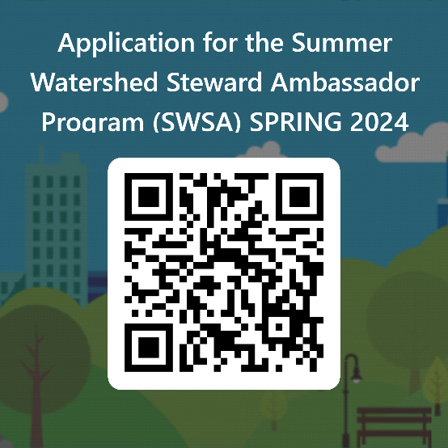Current Danbury High School Science Students (Junior Status in Aquatic Science Preferred)
- Current 2.3 or higher cumulative GPA
- Interested in working outdoors after school this spring.

Spring 2024
Dates: Option 1: April 15th - April 19th – Spring Break
Option 2: May 6th – May 31st – After School
Stipend: Option 1 - 20 hours a week (4 hour a day; $48/day)
Option 2 – 10 hours a week (1-2 hours a day; $24/day)

Please go here to apply online: https://forms.office.com/r/PTBbzuRA2i Or scan the QR-Code

Deadline: Monday March 4th *Special consideration to Aquatic Science students.

If you have any questions, contact Maria Silva Outreach Coordinator, for Finding Our Way, guimaraes007@wcsu.edu
Oﬃce Phone: 203-837-8753 SB148.

