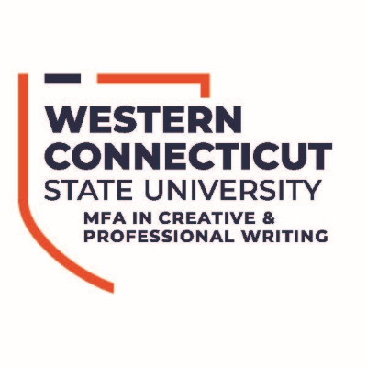
Master of Fine Arts in Creative and Professional Writing
Dublin Residency
Fall 2024

Dear Applicant,
Thank you for your interest in WCSU’s MFA in Creative and Professional Writing’s Dublin Residency. This residency will run from October 23, 2024 – November 2, 2024. Prospective and current students, as well as alumni and writers who are not WCSU students, are welcome to apply. Writers outside of WCSU must submit a writing sample (5-10 pages) in addition to this application.
MFA students attending the Dublin program will fulfill one residency credit. Prospective students who apply and are accepted into the MFA program may apply the Dublin residency toward their degree requirements.
Students will be accepted based on their responses to the application questions below. In addition, the review committee aims to accept a variety of students in terms of genre and professional goals/interests.
Please email the completed application and writing sample to Associate Professor/MFA Coordinator Anthony D’Aries at dariesa@wcsu.edu by March 1, 2024.

Name:
Address:
Phone:
Email:

If currently an MFA student:
Anticipated Year of Graduation:
Number of Residencies Attended:
Primary Genre:
Second Genre:

List topics related to your primary genre that you would like to see covered at the Dublin residency:

List topics related to your second genre that you would like to see covered at the Dublin residency:

If accepted, would you be interested in sharing a hotel room with a fellow writer to reduce costs?

Why do you want to attend the Dublin residency? How do you see this experience benefiting your writing and career goals? (200 words max.)

What obstacles, if any, do you foresee preventing you from attending? Is there anything the program can do to assist you?

If you are not accepted into this year’s Dublin residency, would you like to be added to the waitlist for future residencies?

If you are not a current MFA student, please attach a 5-10 page writing sample (all genres welcome).

